C++ Database Connection Pool
Users Guide

Last Saved On: 11/8/26 9:55 AM

Revision History
Date: | Version: | Description: | Author:
01/20/03 | 1.0 | Initial Draft | John Bramlett
1/21/03 | 1.1 | Updated configuration parameters to include user id, password, and connection string.  Added appendix providing a brief description of all the classes that make up the pool. | John Bramlett

Table Of Contents
Table Of Contents 4
Introduction 1
Configuration Options 1
Using the Service 4
DBPool 6
DBConnectionPtr 7
DBConnection (and specialization OracleConnection) 8
Underlying Database Connection 9
Extending the Service 10
Subclass DBConnection 10
Incorporate with DBConnectionFactory 10
Appendix A: C++ Database Connection Pool Manifest 11
Independent Classes 11
C++ Database Connection Pool Classes 12

Introduction
One of the most expensive operations in database-centric applications is the process of acquiring a new connection to the database. Therefore, one of the most common performance optimizations that can be done for an application is incorporating what is known as a database connection pool. A database connection pool is a service that is responsible for optimizing the process of getting database connections by basically caching connections therefore having them at the ready for whenever the application needs a database connection. Instead of acquiring a new connection on each call the service provides the caller an already initialized database connection avoiding the overhead of this process throughout the application.

This document describes a database connection pool that is written in C++ and provides the following primary features:

- Run-time configuration through externalized configuration file
- Supports multiple data sources
- Thread-safe
- Extensible

The current implementation only supports Oracle databases using Oracle’s OCCI but the service can be extended to support any database type or database driver type.

The remainder of this document outlines the details of this connection pool.

Configuration Options
One of the key features of this implementation is the configurability offered through an externalized configuration file. This configuration is based on the PropertyConfigurationUtility class, which provides for a java-like property file so the form of the configuration is the following:

ConfigurationKey=value

The database pool configuration service relies on a system environment variable to define the name and location of the configuration file. This environment variable is defined as:

DBPOOL_CONFIG

This environment variable should provide the path and filename to the file containing the configuration information for the connection pools.

As noted earlier the connection pool supports the configuration of multiple data sources – this feature allows the system to pool connections across multiple databases (including multiple database types). Therefore most of the configuration options are “scoped” by a given database connection pool name. A pool name represents a logical name for a pool – something that is easier for a user of a given pool to know. In order for the pool to configure itself, the set of logical pool names must first be defined and these values are defined in the pool configuration file (along with the pool definitions). The key for the set of logical pool names is pools. The value associated with this key is a comma separated list of logical pool names. The following is an example configuration entry defining 2 connection pools, one called default and a second called oracle:

pools=default,oracle

There is a second global configuration option related to the above, the default pool. This configuration option defines what pool should be used in the event the user fails to request a connection from a specific pool. This configuration option key is defaultPool. The following is an example configuration entry that identifies the oracle logical pool name as the default pool:

defaultPool=oracle

The remaining configuration options are specific to a given connection pool. In order to distinguish the configuration options across multiple pools the configuration entries for each pool are scoped or qualified by the logical name of the connection pool. Therefore, the general pattern of the pool specific configuration options is the following:

poolName.configurationOption=value

The following chart outlines the set of pool specific configuration options available and their meaning:

Configuration Option | Description
initialPoolSize | Defines the number of connections that will be created when the pool is first initialized. This number does not limit the number of connections in the pool but just defines the initial size of the pool – the pool can grow to the max pool size as needed.
maxPoolSize | The maximum number of connections that should be created in the pool. This option allows you to limit the number of connections that will be created in the pool.
poolIncrement | This option defines how many connections should be created when the pool size needs to grow. When all of the connections are in use, the pool will automatically create more connections (up to the max allowed) with this number defining how many should be created at a time.
waitForConnection | This flag can only have a value of Y or N. This flag indicates whether the pool should wait for a connection to become available if none are immediately available in the pool (this will only occur if the pool is at it’s maximum size and all connections are in use). A value of Y will cause the pool to wait until a connection is available, a value of N will cause an exception to be thrown when no connection is available.
connectionWaitPeriod | This option allows the user to define how long the pool should wait polling for a connection when none is available. This option is defined in seconds – thus if not connection is immediately available and the waitForConnection flag is set to ‘Y’ the pool will poll for a connection for this option number of seconds. If no connection becomes available in this time period and exception will be thrown indicating no connections are available.  A value of –1 results in an infinite wait.
validateConnectionBeforeReturning | This options has valid values of Y and N and defines whether or not the connection should be tested prior to returning it to the caller to insure the connection is valid. A value of Y results in the connection being tested and only if the connection passes the test will it be returned. A value of N means the connection will not be tested prior to returning.
connectionType | The option defines the type of connection that should be created. Currently the only valid value for this entry is Oracle.
userId | The user id that should be used when connecting to the database.
password | The password for the user id that should be used when connecting to the database
connectString | The connection string that is used to connect to the database.

The following sample configuration file shows the configuration of two connection pools and their specific settings:

pools=default,oracle
defaultPool=oracle

# configuration of the pool named default
default.initialPoolSize=2
default.maxPoolSize=10
default.poolIncrement=2
default.waitForConnection=Y
default.connectionWaitPeriod=5
default.validateConnectionBeforeReturning=Y
default.connectionType=Oracle
default.userId=scott
default.password=tiger
default.connectString=804

# configuration of the pool named oracle
oracle.initialPoolSize=2
oracle.maxPoolSize=10
oracle.poolIncrement=2
oracle.waitForConnection=Y
oracle.connectionWaitPeriod=5
oracle.validateConnectionBeforeReturning=Y
oracle.connectionType=Oracle
oracle.userId=scott
oracle.password=tiger
oracle.connectString=804

Using the Service
There are four main components to this service – the service, a smart-pointer connection wrapper, an underlying connection wrapper, and the database connection itself. Figure 1 provides a simple class diagram showing the classes and their relationships.

The following will provide an API overview of the primary classes in the service following by a code example.
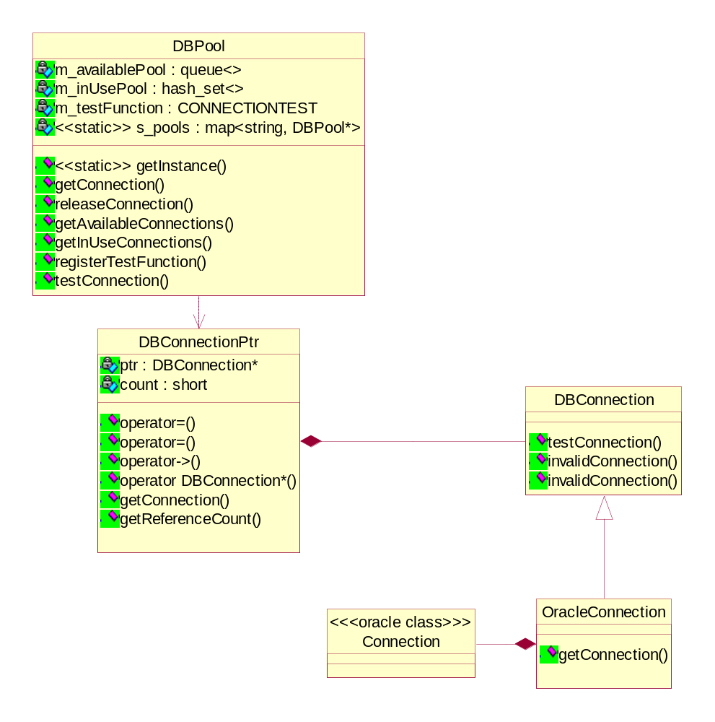
Figure 1: C++ Database Connection Pool Primary Classes

DBPool
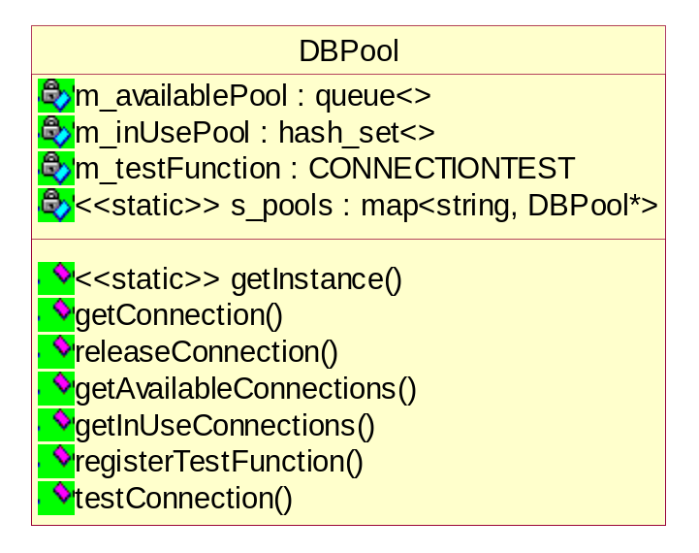
This is the entry point for interactions with the connection pool and serves as the controller of the connections themselves. A user asks the DBPool for a connection when a new database connection is needed. The pool works similar to a singleton in that it is accessed through a static getInstance method, however, this method takes an optional parameter which is the logical name of the connection pool being requested. If no value is provided the default pool (as specified in the configuration file) will be returned.

The following is an example of requesting a connection from the oracle connection pool:

DBConnectionPtr connection = DBPool::getInstance(“oracle”).getConnection();

The getConnection method is the primary API that a user of the pool will interact with (releasing the connection back to the pool is the responsibility of the DBConnectionPtr class). In addition, the user can define an external function for the pool to use whenever a connection needs to be tested. This configuration of the pool should occur once within some application start-up code. The remaining API are for debugging and troubleshooting. The following table provides a brief overview of the API on DBPool:

Method | Description
getInstance | Static method used to obtain an instance of a specific database connection pool. If no pool name is given when this is invoked the default pool from configuration is used.
getConnection | Returns a connection from the pool.
releaseConnection | Releases a connection back to the pool. In general the user of this service is not responsible for this clean-up, instead the DBConnectionPtr class has been developed to manager releasing a database connection back in to the pool.
registerTestFunction | Registers a function that the pool should use when a connection needs to be tested.
getAvailableConnections | Returns the number of connections that are currently available (not in use) in the pool.
getInUseConnections | Returns the number of connections currently in use by the application.

DBConnectionPtr
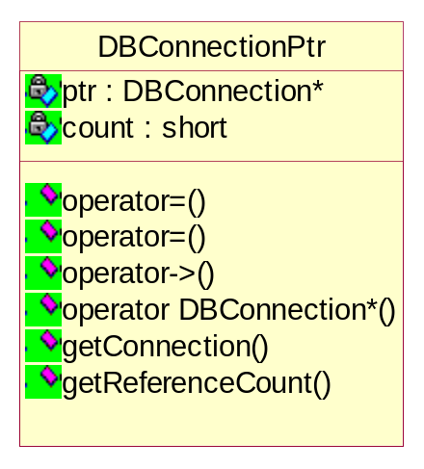
The DBConnectionPtr is a “smart-pointer” wrapper around a database connection. This class uses referencing counting to insure the proper releasing of a database connection back to the pool upon a client completing their task (i.e. when this object goes out of scope and there are no other references to this object the underlying database connection is released back to the pool).

As this class’ sole responsibility is to manage the user-side life of the connection it doesn’t offer any useful functionality beyond system functionality. There are two primary ways in which this class will be used, through the getConnection API or through the overloaded -> operation – both of which return a reference to the underlying database connection wrapper.

DBConnection (and specialization OracleConnection)
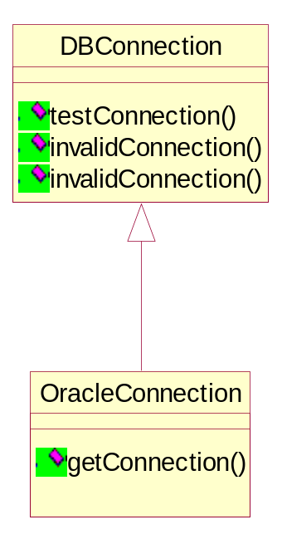
This layer provides a very thin, common encapsulation layer for all database connections. Since C++ does not natively provide a common representation of a database connection (i.e. it is vendor specific though there are specifications such as ODBC) this layer was necessary to insure some level of commonality across all database connection types. The API for these classes centers around getting the underlying database connection (Note: this layer could be expanded in to providing a common database API for all databases with the specializations such as OracleConnection noted above providing database driver specific implementations of the API but there seemed little value in such an undertaking at this time).

The following table describes the API:

Method | Description
testConnection | Default implementation of a database operation that can be used to test the connection. If a function is registered with the pool this function will not be used.
invalidConnection | Property that defines if the underlying database connection is valid. This API provides a facility for a user of a database connection to identify it as being invalid and therefore should not be placed back in the pool when the connection is released.
getConnection | Provides back to the caller the underlying database connection. This method must be specialized by each database to identify the appropriate representation of a connection.

Underlying Database Connection
The final piece to the puzzle is the actual database connection itself. This is database specific so there is no formal model of this.

The above defines the set of components that make up the database connection pool. The following is a code sample of using the pool:

try {
// get a connection to the database – we know we want to use
// connection pool ‘oracle’
DBConnectionPtr connectionPtr=DBPool::getInstance(“oracle”).getConnection();

// to execute on our connection we need to create a statement so we
// need to first get our underlying oracle connection
DBConnection* dbConnection = connectionPtr.getConnection();
OracleConnection* oracleConnection = (OracleConnection*)dbConnection;

Connection* lCon = oracleConnection->getConnection();

// now create a statement
Statement* lstmt;
lstmt = lCon->createStatement(
…
// some sql call
…);

// do any parameter work
…

// execute our query
lstmt->executeQuery();

// process the result of the query
…

// you still have to clean-up the statement
lCon->terminateStatement(lstmt);

// as soon as we hit this closing brace our connection will
// be released back to the pool as part of the destructor
// of the DBConnectionPtr so there is no clean-up of the
// connection required of the user of this service
}
catch (DBException dbex)
{
// handle exceptions
…
}
catch (SQLException sqlex)
{
// handle exceptions
…
}
catch (...)
{
// handle exceptions
…

}

NOTE: As you can see from the above the process of getting to the underlying connection that you can actually use is cumbersome. I’m yet to come up with a good solution that supports the functionality we wanted without created a complete multi-database encapsulation layer (or the use of such a facility such as RogueWave’s DBTools). In the case of Oracle this service could be changed using multiple inheritance where the OracleConnection class inherits from both Connection (the Oracle OCCI class) and DBConnection but that does not solve this problem for other databases.

Extending the Service
As has been noted the current implementation of the service only supports Oracle through OCCI however, this service can easily be extended to support other databases. There are two pieces that would need to be implemented to provide support for a new database type. The first is to provide a database-specific implementation of the DBConnection class (see OracleConnection). The second is to incorpoate this new class in to the DBConnectionFactory factory which is responsible for creating new connections as well as for releasing connections.

Subclass DBConnection
There are no special requirements for subclassing DBConnection so the implementation is left to the developer’s discretion though it is recommended to provide an API to obtain a reference to the database-specific underlying connection.

Incorporate with DBConnectionFactory
Incorporating this new subclass of DBConnection in to the DBConnectionFactory is relatively trivial. You should create a connection type that is used in the configuration of the pool to identify your new connection type and then implement the functionality to obtain a new database connection as necessary in the createConnection call (this API takes in the pool name so the DBPoolConfiguration should be used to obtain the connection type along with any connection-specific parameters). The factory also takes on the responsibility of cleaning up the connection so any special clean-up required should be implemented in releaseConnection (though the bulk of the cleanup should occur in the destructor of the database-specific subclass of DBConnection).

Appendix A: C++ Database Connection Pool Manifest
The following table outlines the files that make up the C++ Database Connection Pool. It is broken down in to 2 types of files, those that can be used outside independent of the connection pool and those that are specific to the connection pool.

Independent Classes
The following table defines the set of classes that are used by the C++ Database Connection Pool service but are not specific to the pool implementation (i.e. they are reusable components that could live and be used elsewhere in an application).

Class Name | Description
ConfigurationUtility (ConfigurationUtility.h) | The base class of all configuration class. This is an abstract class in that it only defines the API that a configuration utility must implement.
PropertyConfigurationUtility (PropertyConfigurationUtility.h) | This class implements a key-value based configuration that works similar to java property files.
Debugger (DebugUtil.h) | This class is used for writing out messages for tracing application flow or for general debugging. The intent is to encapsulate cout-like functionality in a class so cout’s are not used directly. This way the specified output form used is determined by this utility instead of the application developer (therefore these debugging messages could be redirected to a file or standard out or some other mechanism – something that can not be done with embedded cout’s)
Mutex (Mutex.h) | A simple implementation of a mutex. A mutex is used to insure thread-safety.
MutexHandler (Mutex.h) | A smart-wrapper around the above mutex class that automatically locks and releases the mutex based on the execution scope. Is provided so a user of the mutex doesn’t have to worry about releasing the mutex it is done automatically when this class (which wraps a mutex) goes out of scope.
TestCase (TestCase.h) | This is the poor-man’s implementation of JUnit and provides basic functionality for executing tests, tracking test status, and provides simple assert functionality. This was something thrown together quickly (the cppunit implementation I found which was a port of JUnit to C++ seemed pretty heavyweight to try and get built in a short period of time).

C++ Database Connection Pool Classes
The following table defines the set of classes that are specific to the C++ Database Connection Pool and therefore cannot live without the pool as a whole. These classes were built to serve as the connection pool and where not intended to be reused in another context.

Class Name | Description
DBConnection (DBConnection.h) | The wrapper class for an underlying database-spec connection.
DBConnectionFactory (DBConnectionFactory.h) | Responsible for creating and cleaning up the specific subclasses of DBConnection based on the connection type defined in configuration (for the given pool).
DBConnectionPtr (DBConnectionPtr.h) | The wrapper class for the DBConnection. This class provides the mechanism for automatically releasing a connection back to the pool once this class goes out of scope – this is used to simplify the responsibilities on the developer using the connection pool (this way they don’t have to remember to put the connection back in the pool)
DBPool (DBPool.h) | The pool itself.
DBPoolConfiguration (DBPoolConfiguration.h) | This is a subclass of PropertyConfigurationUtility and provides the API for getting the configuration parameters for our database connection pool. If a connection has specific parameters that are not defined here they can access the ConfigurationUtility ‘get’ api to get parameters.
OracleConnection (OracleConnection.h) | The Oracle implementation of DBConnection.

